**Semper Safe**

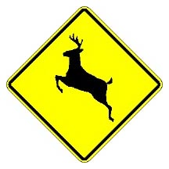



**Hunting - Wildlife Safety**

Hunting safety, I’m sure those words mean different things to different people. The thing that should stand out to most hunters though is that hunting safety means gun safety. But as Military folk we all know and apply gun safety, right? So why does the average number of hunting accidents in the U.S. stay around 240 per year with an average of 20 being fatal (Reference International Hunter Education Association (IHEA)? They didn’t follow basic hunter’s safety. With the hunting season come hazards for non-hunters as well, and that is deer-related vehicle crashes. Deer collisions become more frequent during fall and winter due to deer migration and mating season, which typically occur from October through December. About 1.5 million deer-vehicle collisions happen each year in the U.S. according to the National Highway Traffic Safety Administration (NHTSA). Those accidents cause about 150 deaths and $1.1 billion in property damage annually, again according to NHTSA. Let’s cover some basic safety guidelines for hunting and some tips to help avoid deer-related vehicle crashes.

* Take a free hunter safety course -- knowing the rules is the key to safe hunting (required in N.C.)
* Firearms (including bows) and alcohol or drugs (including the prescription kind) do not mix
* Treat every firearm and bow as if it is loaded, keep the safety on until you’re ready to shoot
* Wear appropriate clothing for the elements and make yourself visible to other hunters (Deer can’t see colors, so DO NOT wear camo without wearing Hunter Orange)
* Identify your target and beyond, emotions can run high when hunting so look twice, shoot once
* Tell a dependable person where you're hunting and when you plan to return
* If you’re using a tree stand, wear a full body safety harness; 1 in 3 hunters using a tree stand fall from that tree stand
* Always use a cord or rope to raise and lower all equipment in tree stands so you can use three points of contact when climbing up or down which is when most accidents occur

# Commanders, Leaders, and Supervisors: Ensure your personnel are made aware of these safety tips and other precautions to keep their on and off-duty activities mishap free. For more information contact your Base Safety Office, Unit Safety Officer or visit our website at;

***As Marines, Sailors and Civilian Marines we live by our ethos. So think before you jeopardize the safety of yourself, your fellow Marines, Sailors, civilian employees or***

***family members, and remember***

***SEMPER SAFE!*** SS 09-47





**Semper Safe**

**Don’t Take Deer Crossing Signs For Granted**

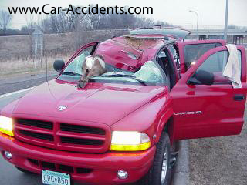

**Slow Down And Drive Cautiously!**

**For more information contact your Unit Safety Officer or Base Safety Representative**

SS 09-47





**Semper Safe**

**Expect the unexpected**  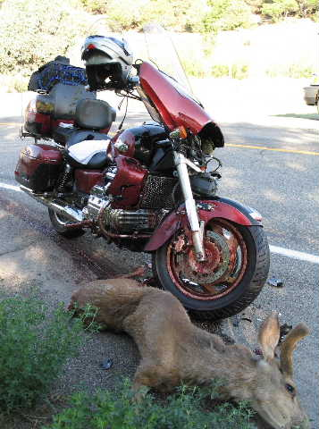

**Look for the hazard…wear all your safety gear all the time!**

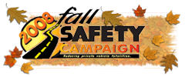

**For more information contact your Unit Safety Officer or Base Safety Representative**

SS 09-47